LEGEND:

* black = raw DLC output
* Blue = remove poorly-predicted values and replace with interpolation
* Red = Filter after interpolating

Daniel’s version: lfilter (size 20)

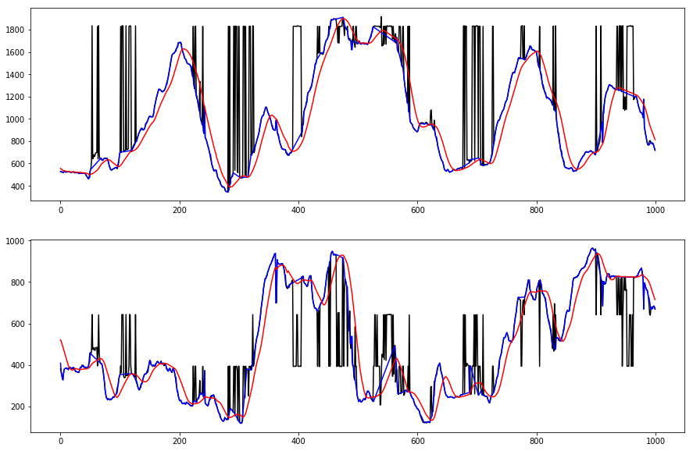

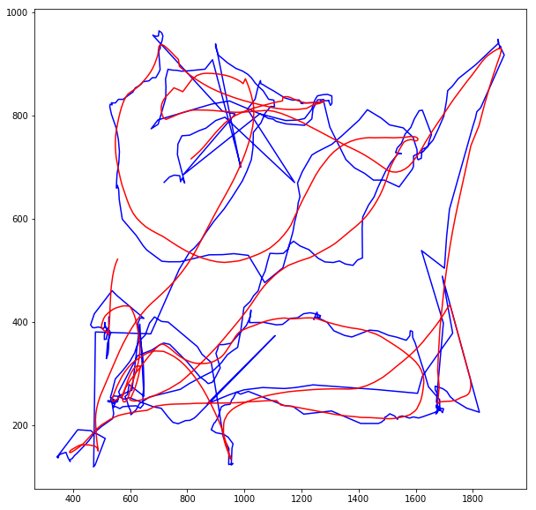

Linear filter (size 20), but in both directions

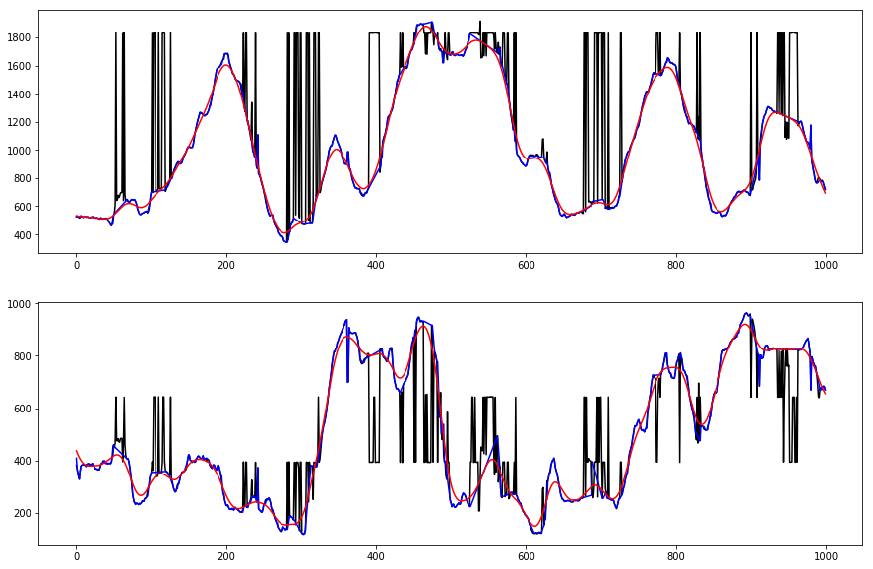

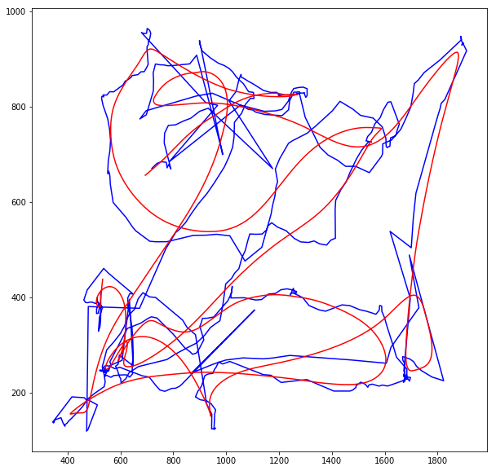

Linear filter both directions, Size 5

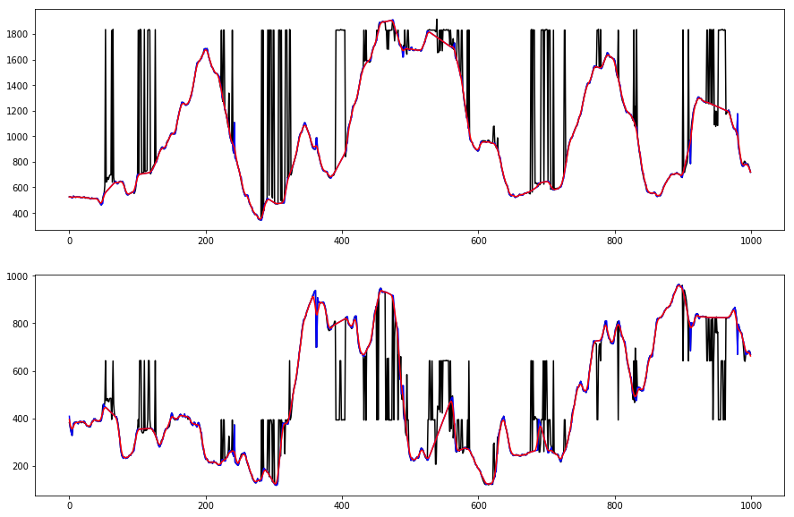

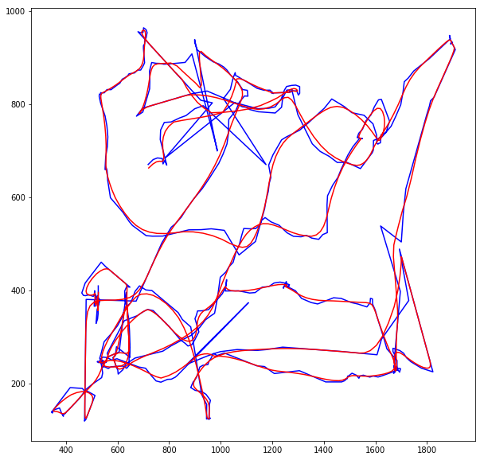

Butterworth, frequency cutoff 0.5

